|  |
| --- |
| CSD+ USER GUIDE |
|  |
| Civica Education  Authored by: Timothy Osmond |

# Change log

|  |
| --- |
|  |
|  |

Link:

<https://chrome.google.com/webstore/detail/csd%20/eonpodbodehkmmppfcjifeepjeknhlbl?hl=en-GB&authuser=0>

# Stored replies

Stored replies scrapes the CSD’s DOM to prepopulate messages anywhere in the system. So if it’s in the CSD it can be in your message.

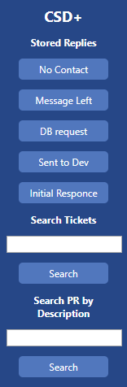Currently there are 5 messages prepopulated in the system, but it has been written modularly so adding new buttons and replies takes minutes.

To use these replies click the button and this will copy the message to your clipboard to then paste into the message window. Be warned this will clear your clipboard and replace it with the generated message.

Buttons that work on with Customer:

* + - * No Contact
      * Message Left
      * DB Request

Buttons that work in Customer Note

* Sent to Dev
* Initial response

**Example:**

In this example we are requesting a database from the customer.

1. As we would only ever send this message from with customer navigate to the with customer screen.

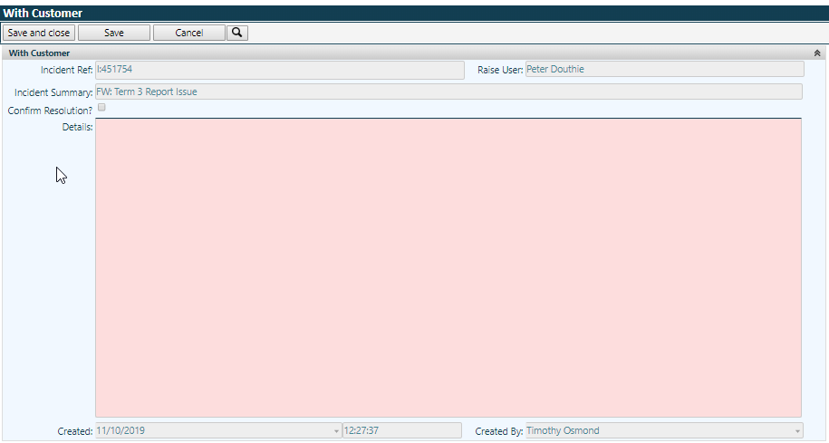

1. Click the appropriate response, DB request in our case.

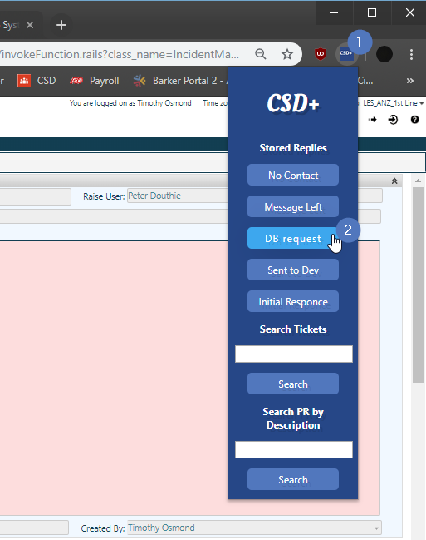

1. This will send the message to your Clipboard, click into the message window and paste it (CTRL + V or right click > Paste)

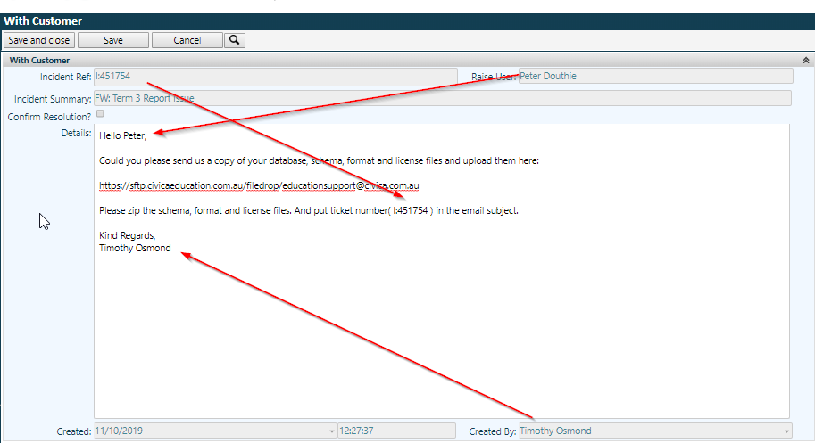

# Searching

Searching with CSD+ is made a lot easier now that you don’t have to navigate the CSD to search for an open ticket or problem record.

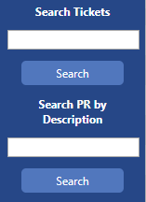Search Tickets:

Type the ticket number of any active ticket and it will find that ticket.

Search PR by Description:

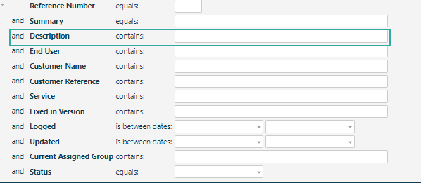This feature will search the description of any problem record in the system.

# Quality of life changes

* Several windows in the CSD have had their height increased for better readability.
* Curves have been removed from the CSD.
* Load time has been added to all windows to better illustrate slowness issues.



* Tab titles have been changed to [Ticket Number] – [Organization]
* Various Minor CSS fixes